EXPERIMENT 2.2

Name: Bhavishya Bansal

UID: 20BCS5997

Course: Business Intelligence Lab Course code: 20CSP-421 Section:20BCS-29-A

# Aim:

# Perform Data Analysis and Visualization using Advanced Excel

# Software Required:

Microsoft Excel

# Description:

# The experiment involves setting up an OLAP system to analyze a dataset and extract meaningful insights. The dataset can be sourced from various data repositories within the organization, such as transactional databases or data warehouses. The OLAP system will enable users to explore the data from multiple dimensions or perspectives, facilitating deeper analysis and visualization

# Pseudo code/Algorithms/Flowchart/Steps:

# Command Used are

# Vlookup

# Filter

# Sort

# Trim

# Remove Duplicates Data

# Arrange Data

# CountIf

# Len()

# Left()

# Right()

# Concatenate()

**Output:**

Filter command used on US dollar in increasing order

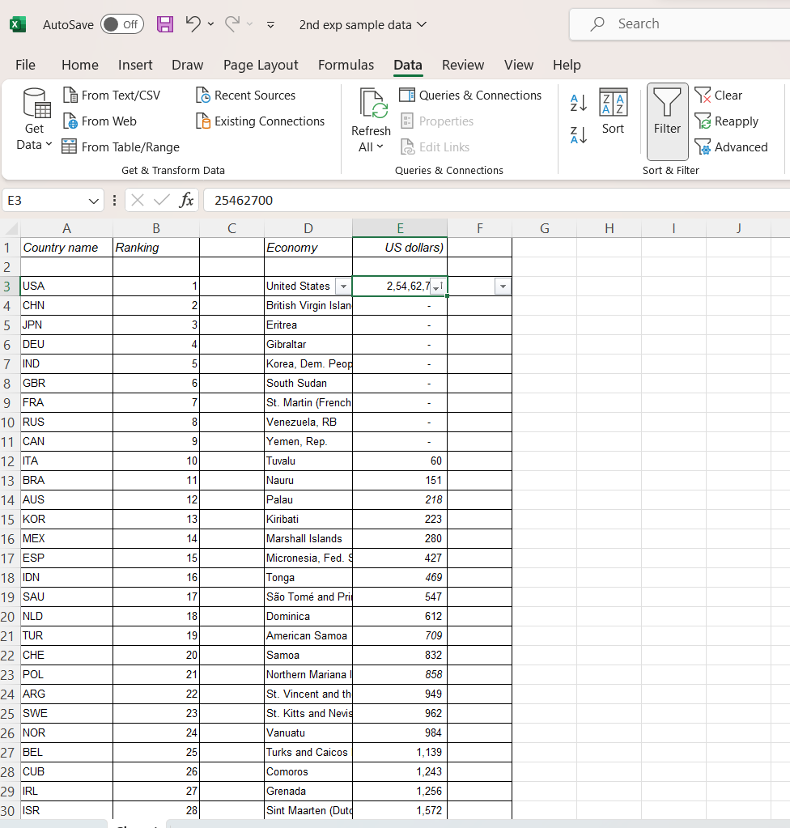

Sort command used on Column D

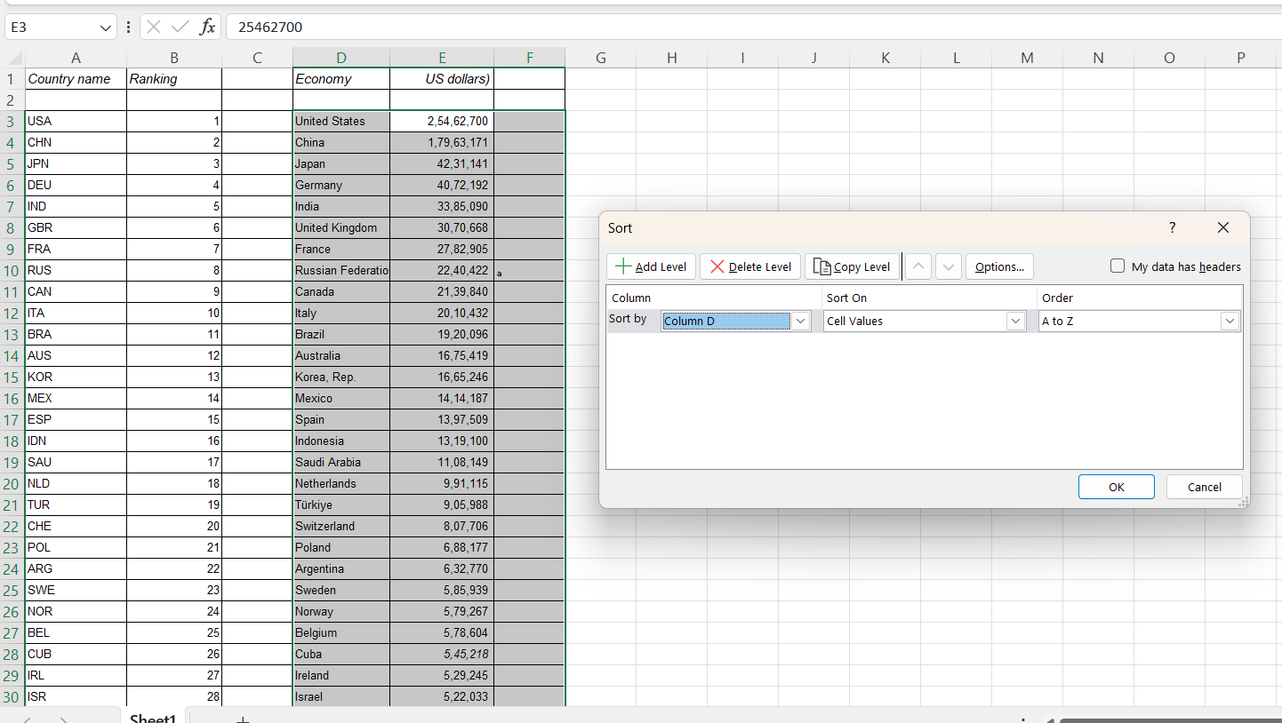

After Sort is performed

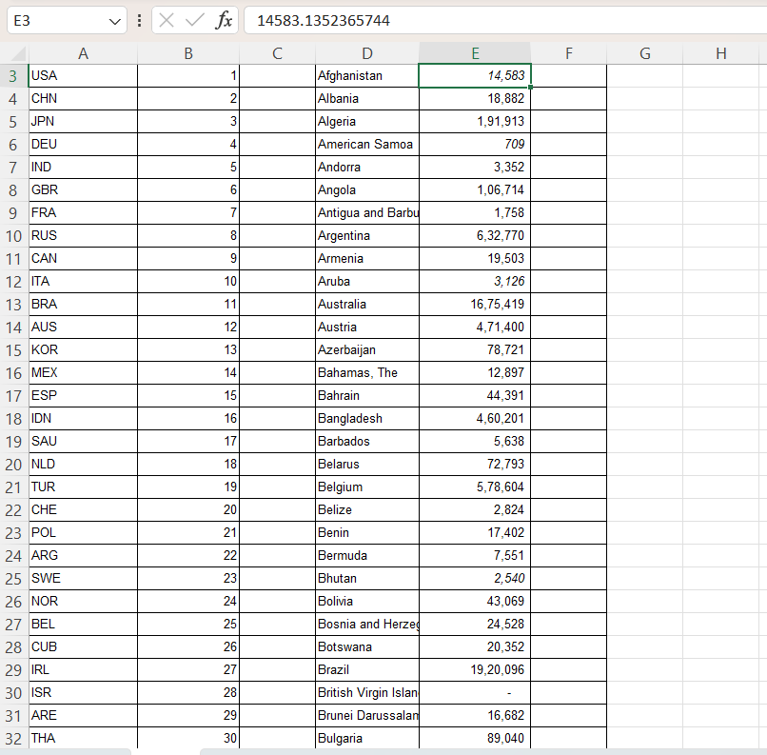

Remove Duplicates

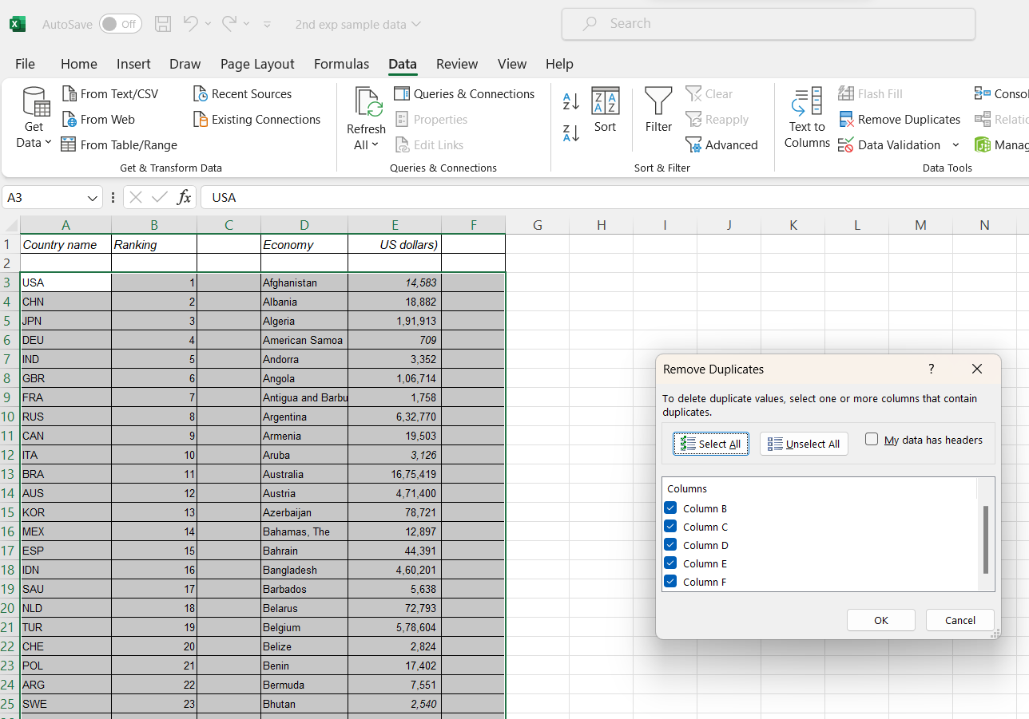

Arrange Command is used on Column D

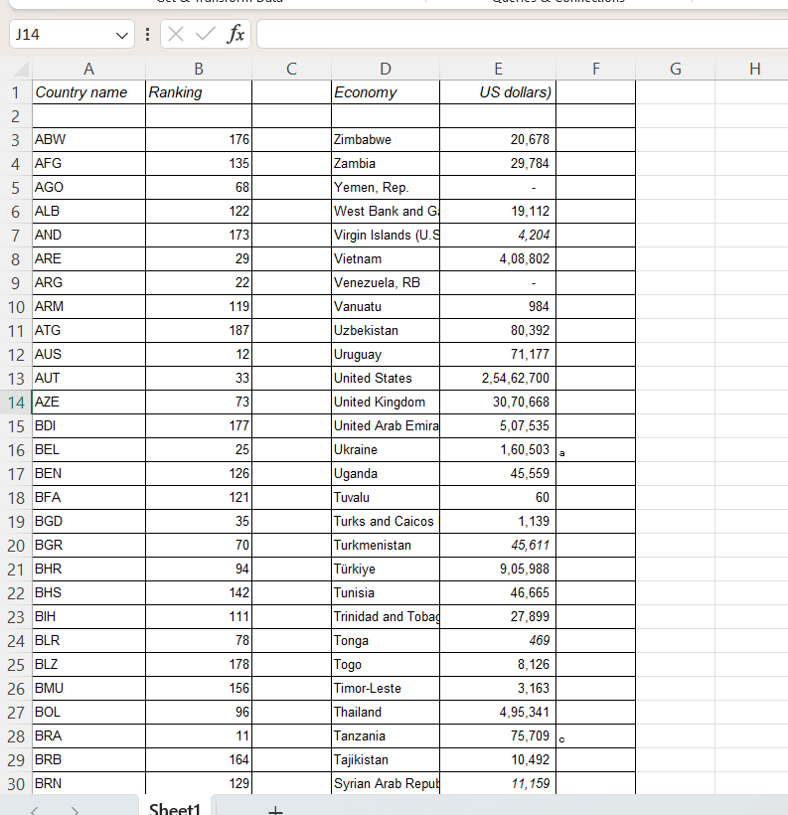

Count-If command used on Column A

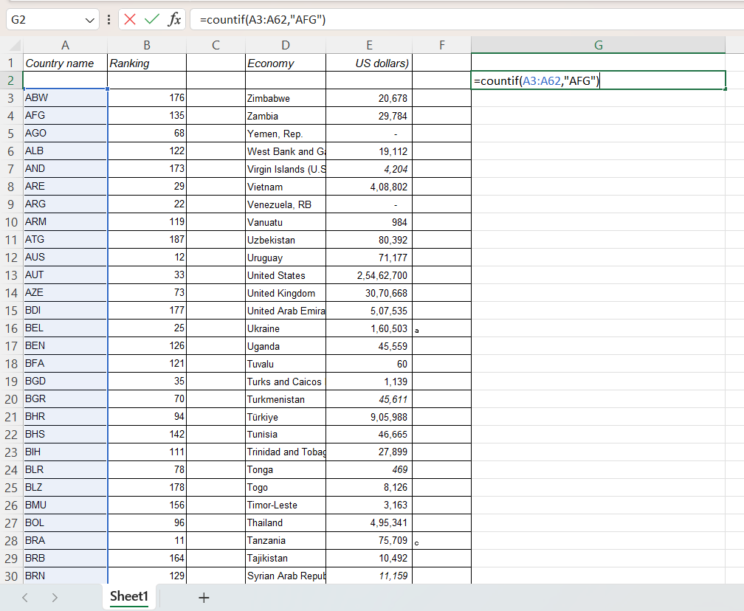

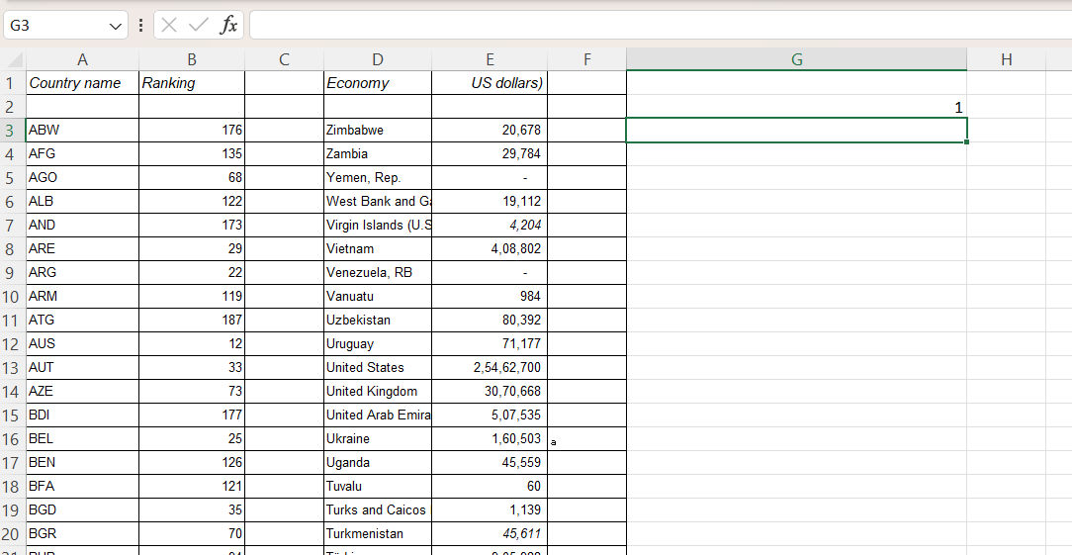

Len Command used on Column D

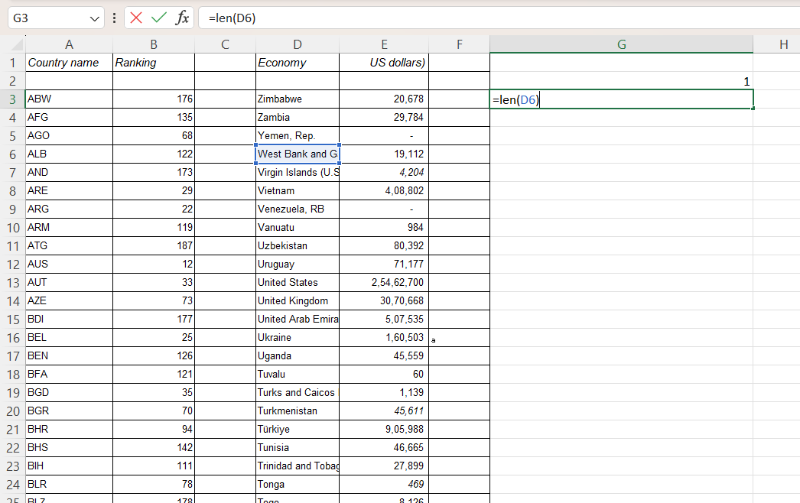

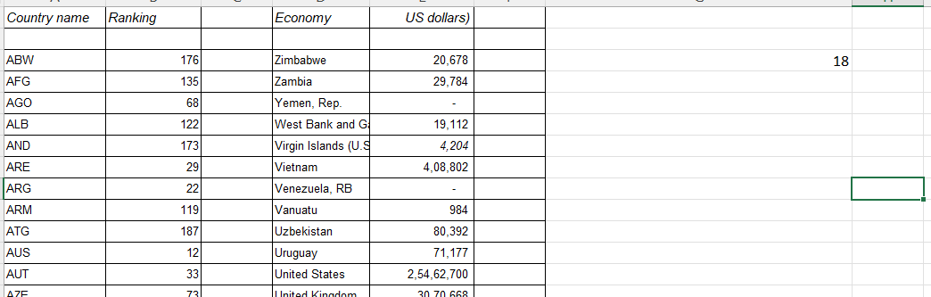

Left command used on Column D

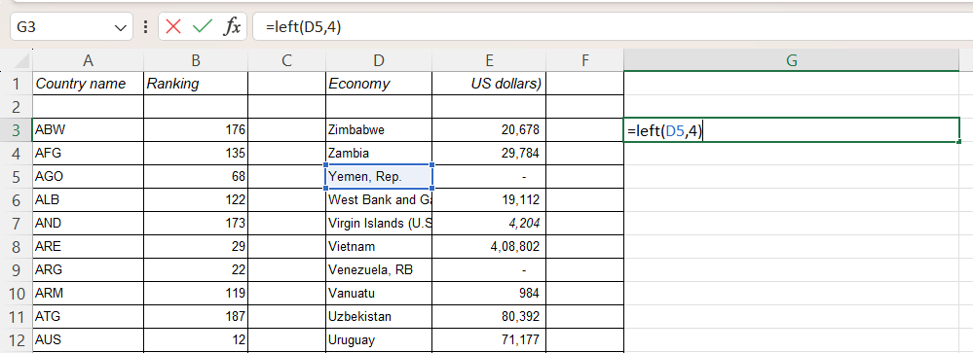

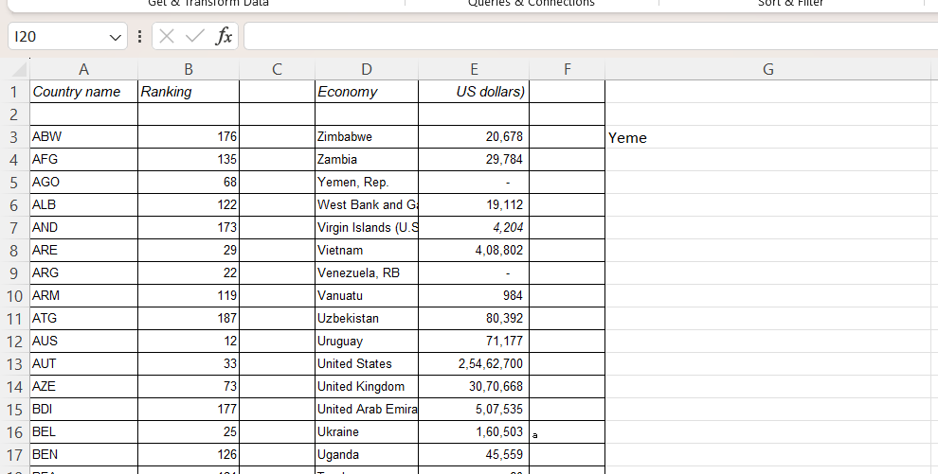

Right Command used on Column D

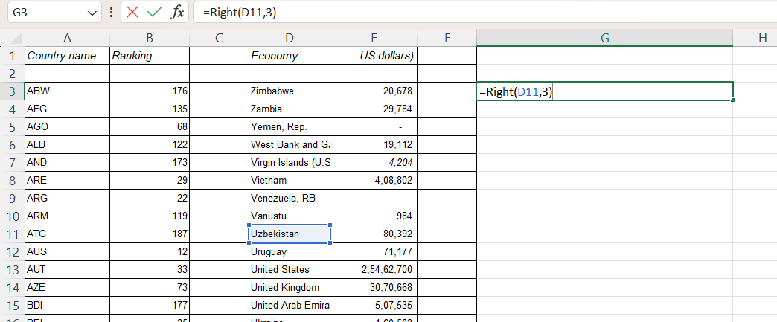

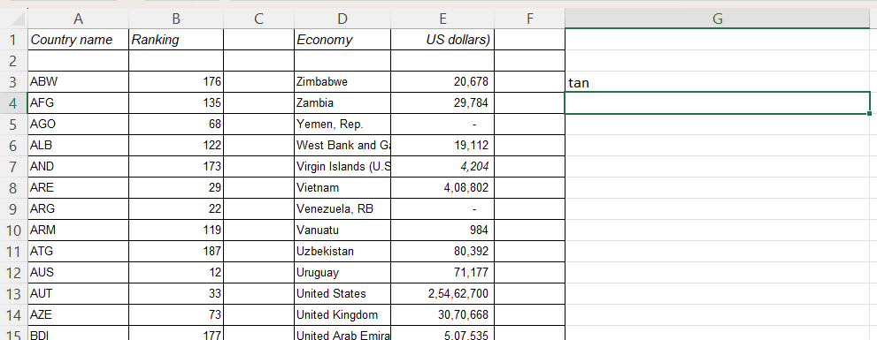

Concat command used on Column D

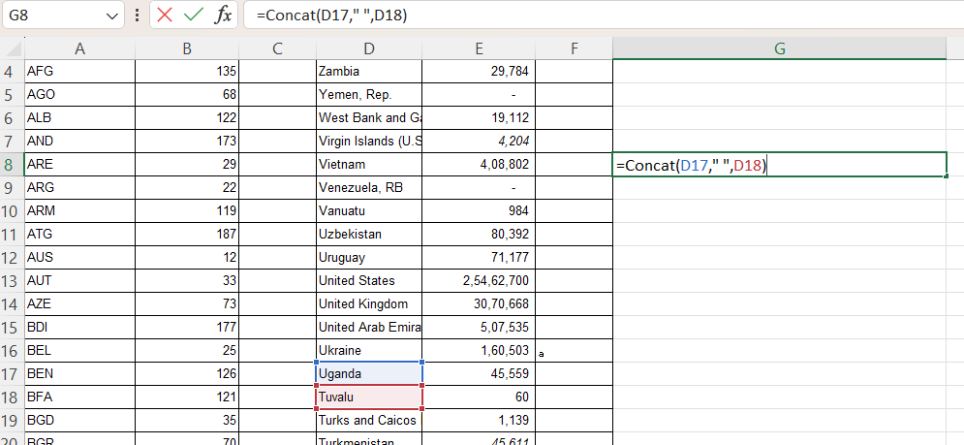

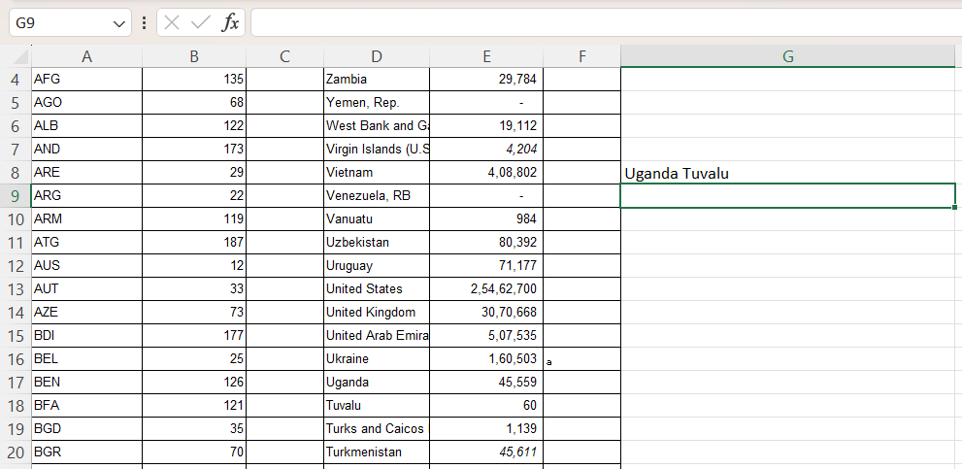

VlookUp Command

